Breakdown reports:

Currently at: https://38.insights.genex.co.za/surveys/daily-reports

Edits:

To be moved to Push Reports - Done
To be called Daily Survey Breakdown Reports - Done
Add Toggle for S900 / SB
Current layout:

- Edit help test “seperated" to “separated” - Done
- Edit “Daily” label to be called “Midnight” - Done
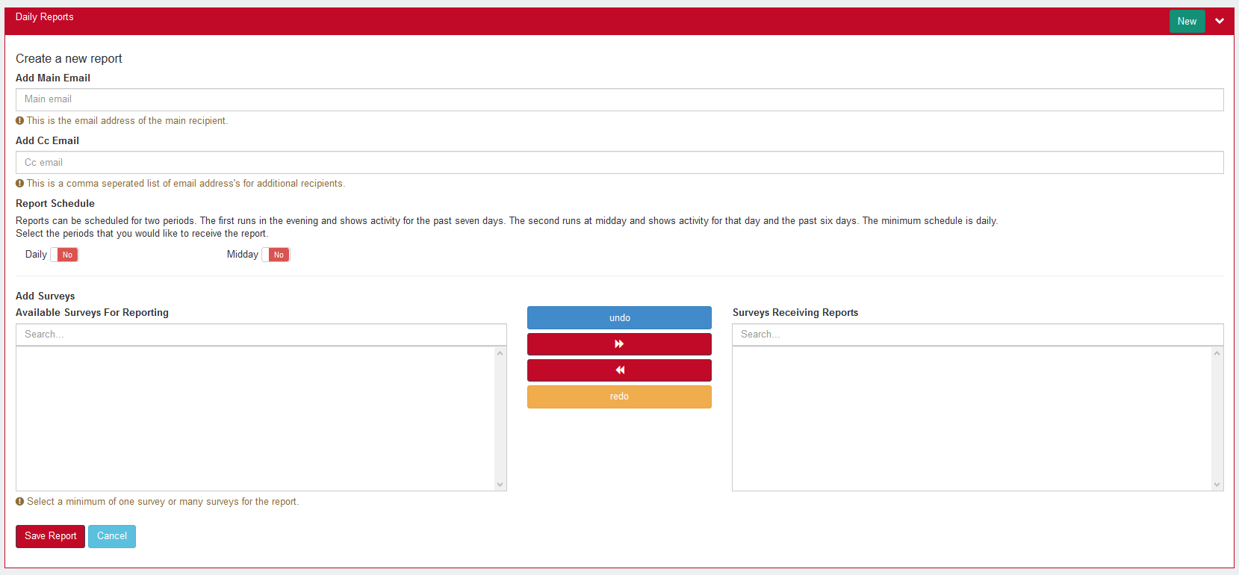

Suggested additions:

A section should be added to the current config before the email inputs to allow for the inputting of demographic filters. A demographic can be selected e.g. country. The user can add demographic value inputs and associate them with a main email address and a comma separated CC list (e.g. country = South Africa; send to support@genex.co.za and CC bob@genex.co.za). Multiple conditions can be added to allow each demographic value to be input with an associated email and CC input. If no demographic is selected, only one email and one CC input field is shown.

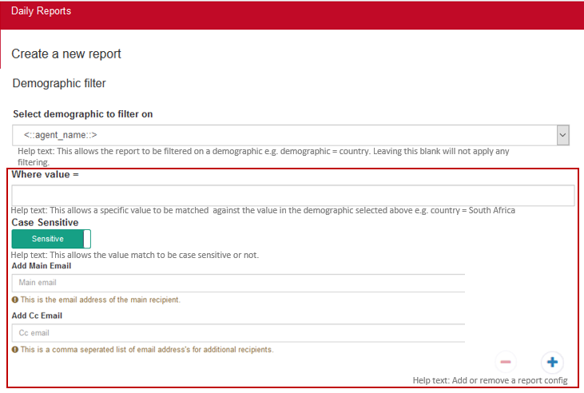
Note: add report config should be greyed out when no demographic filtering is selected; see help text

Report layout:
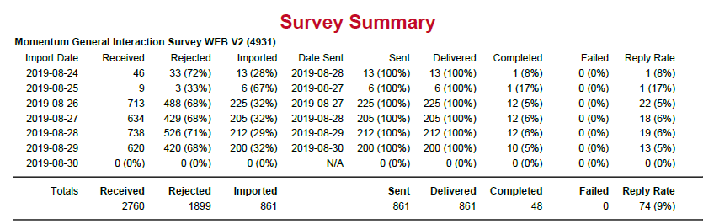
- Edit: Reply Rate in total count should be completed / delivered as per other reply rate stats in report (it is currently replied / delivered) e.g. below should be 48 / 861 = 6%; not 74 / 861 = 9%

